To give temporary access to an S3 object using the AWS Console.
Guys please follow below instructions it will be helpful for Us.

Steps to Generate a Pre-Signed URL in AWS Console

Log in to AWS Console
- Go to AWS Management Console.
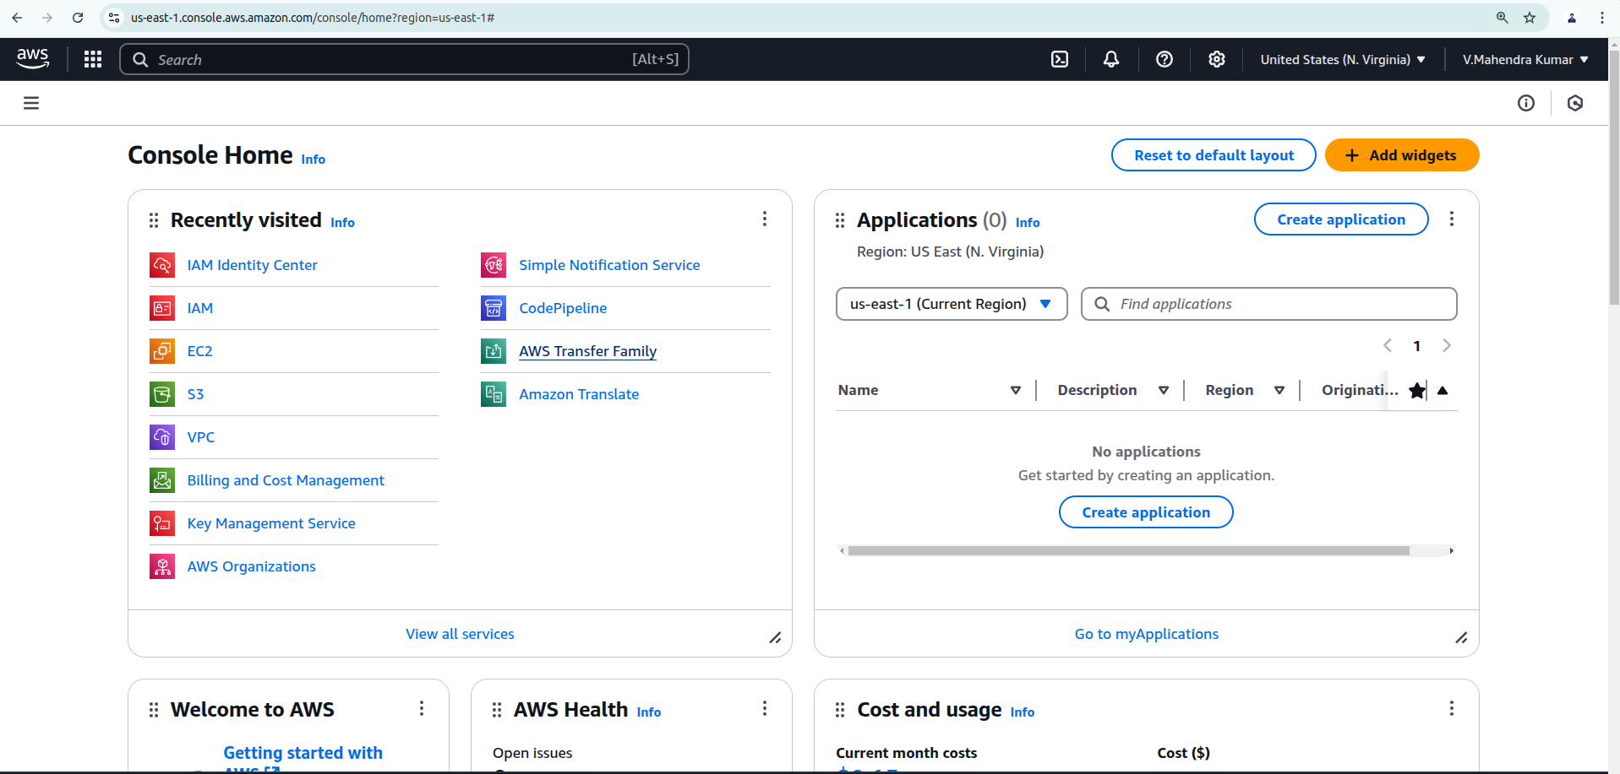
- Navigate to the S3 service.
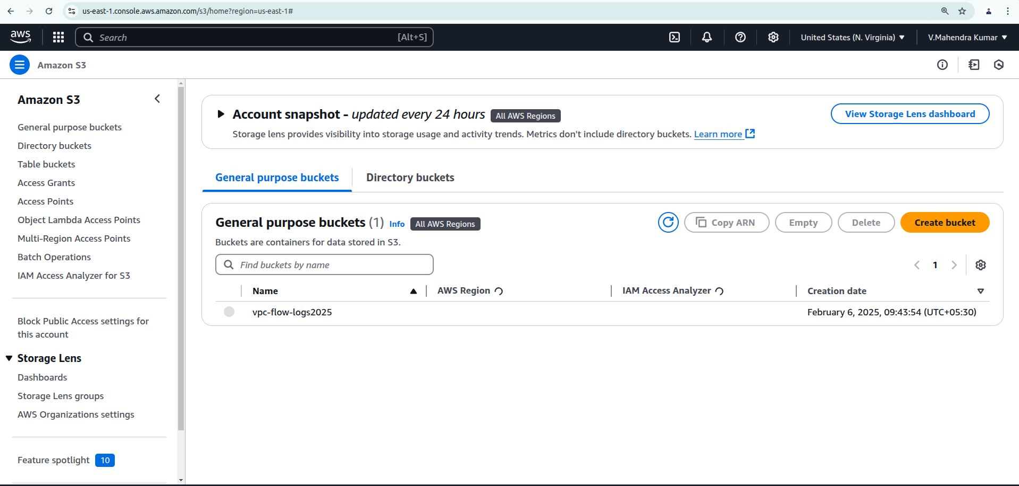

Find Your S3 Object
- Open the S3 bucket containing the file.
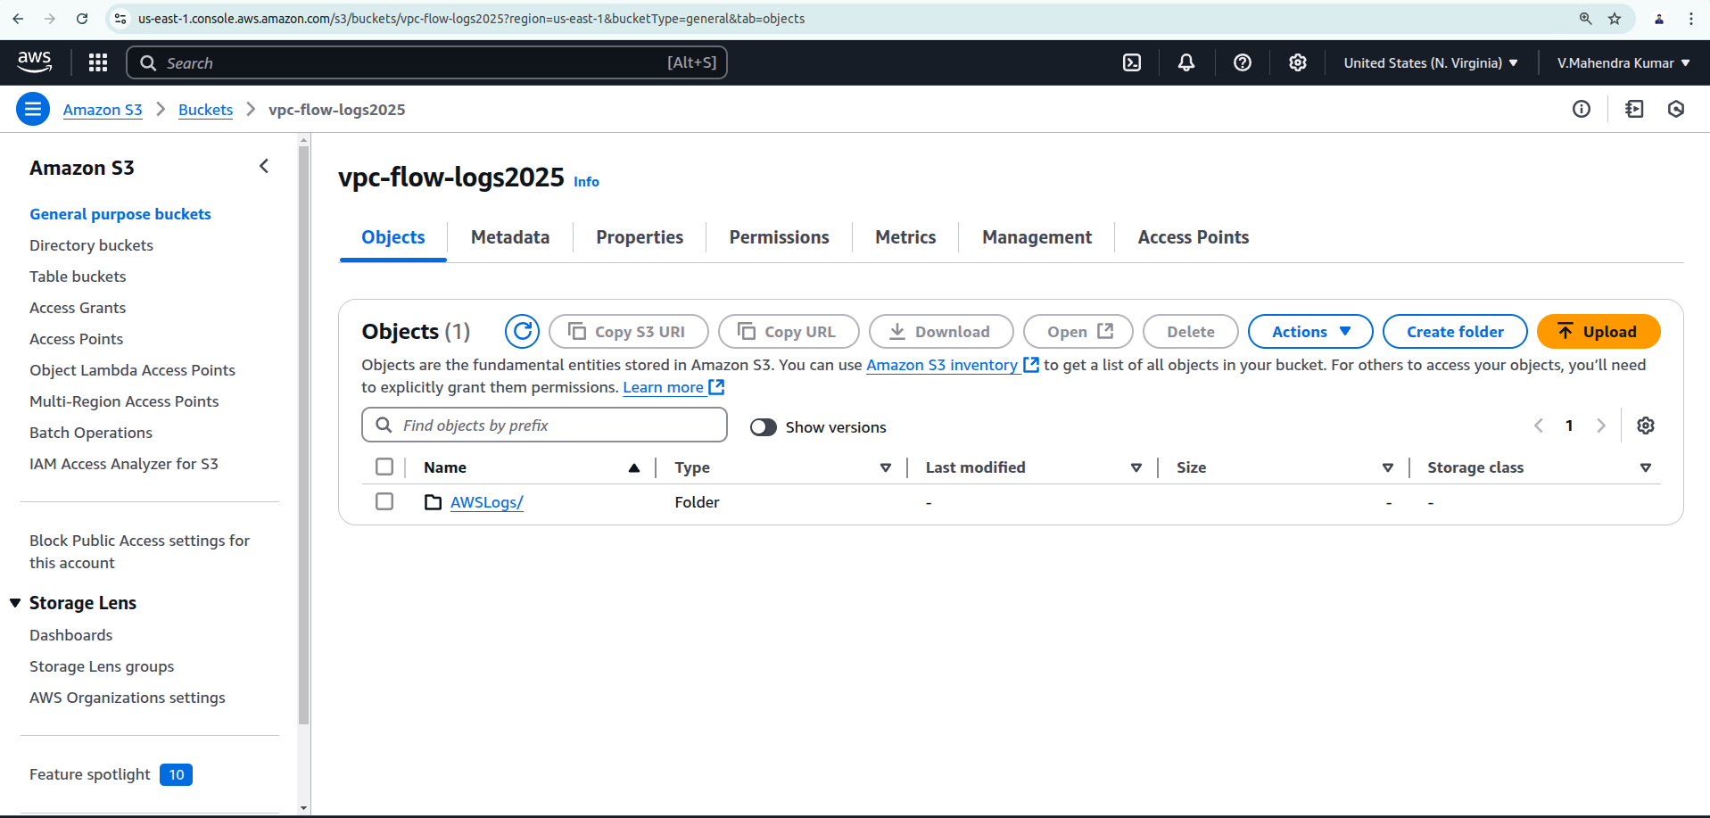
- Locate and click on the object you want to share.
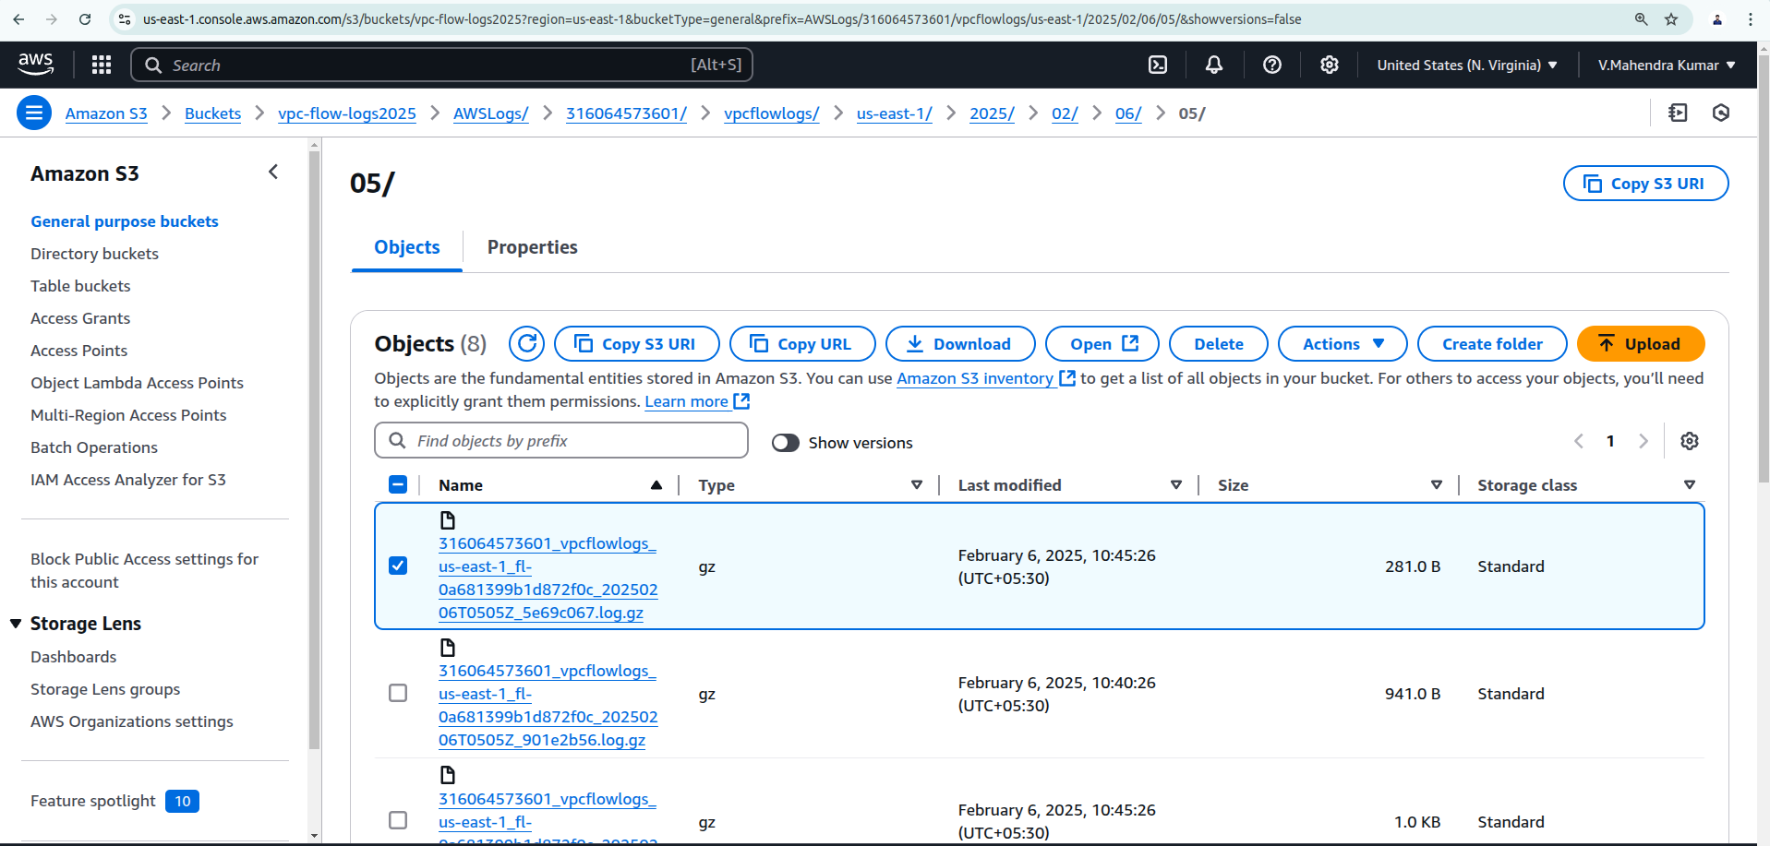

Generate a Pre-Signed URL
- Scroll down to the "Object actions" section.
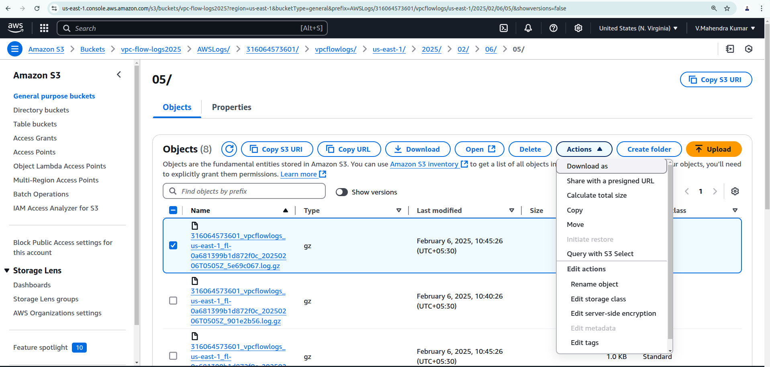
- Click "Create presigned URL".
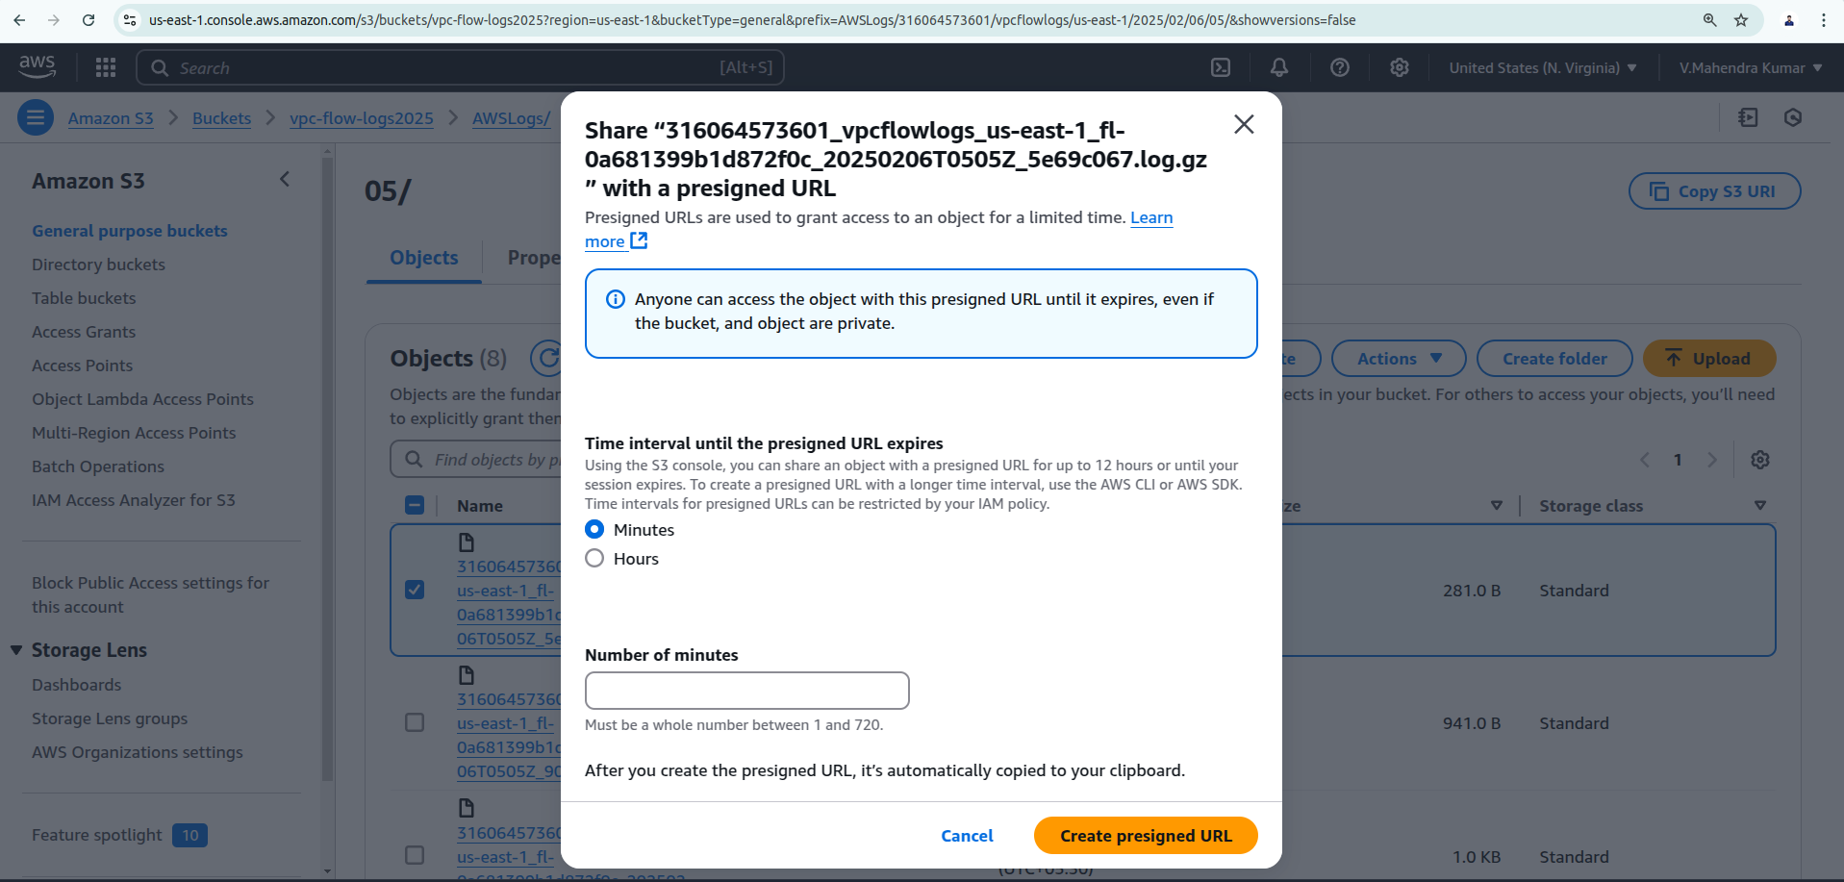
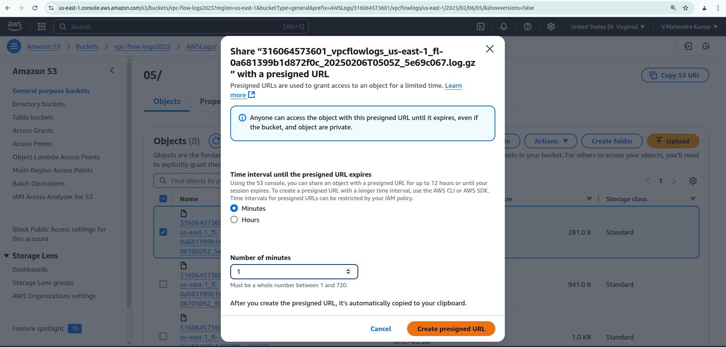
- Set the expiration time (e.g., 15 minutes, 1 hour, etc.).
- Click "Create URL".
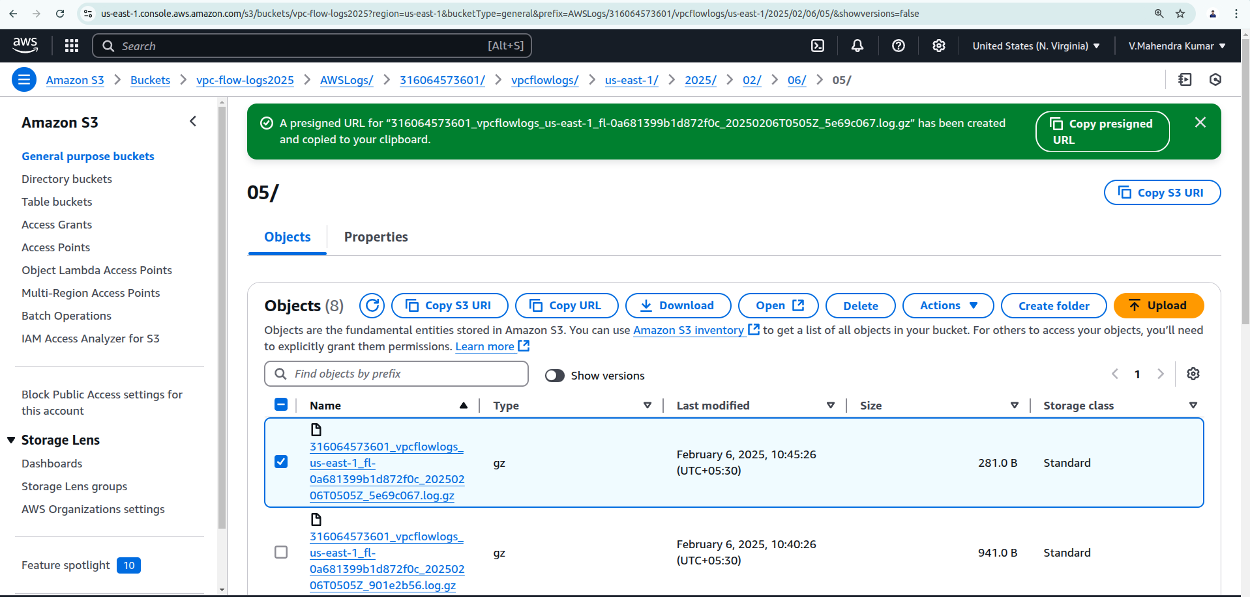
Copy & Share the URL
- Copy the generated URL and share it with the intended recipient.
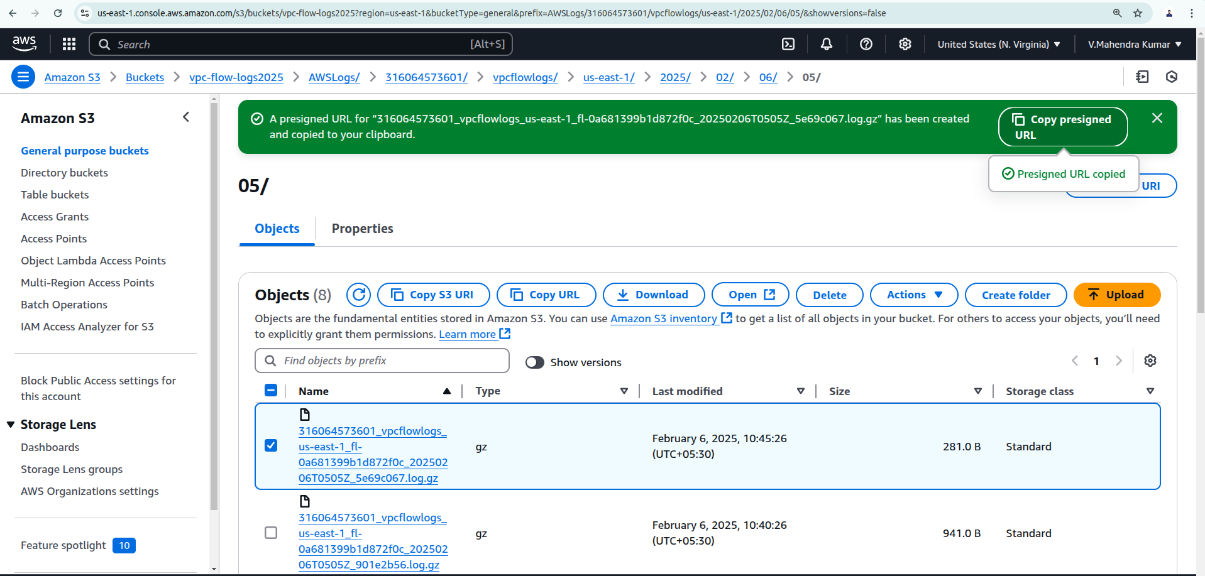
- The User can use this URL to access the file without needing direct S3 permissions.
I can access my object with the given set of time duration and downloaded object.
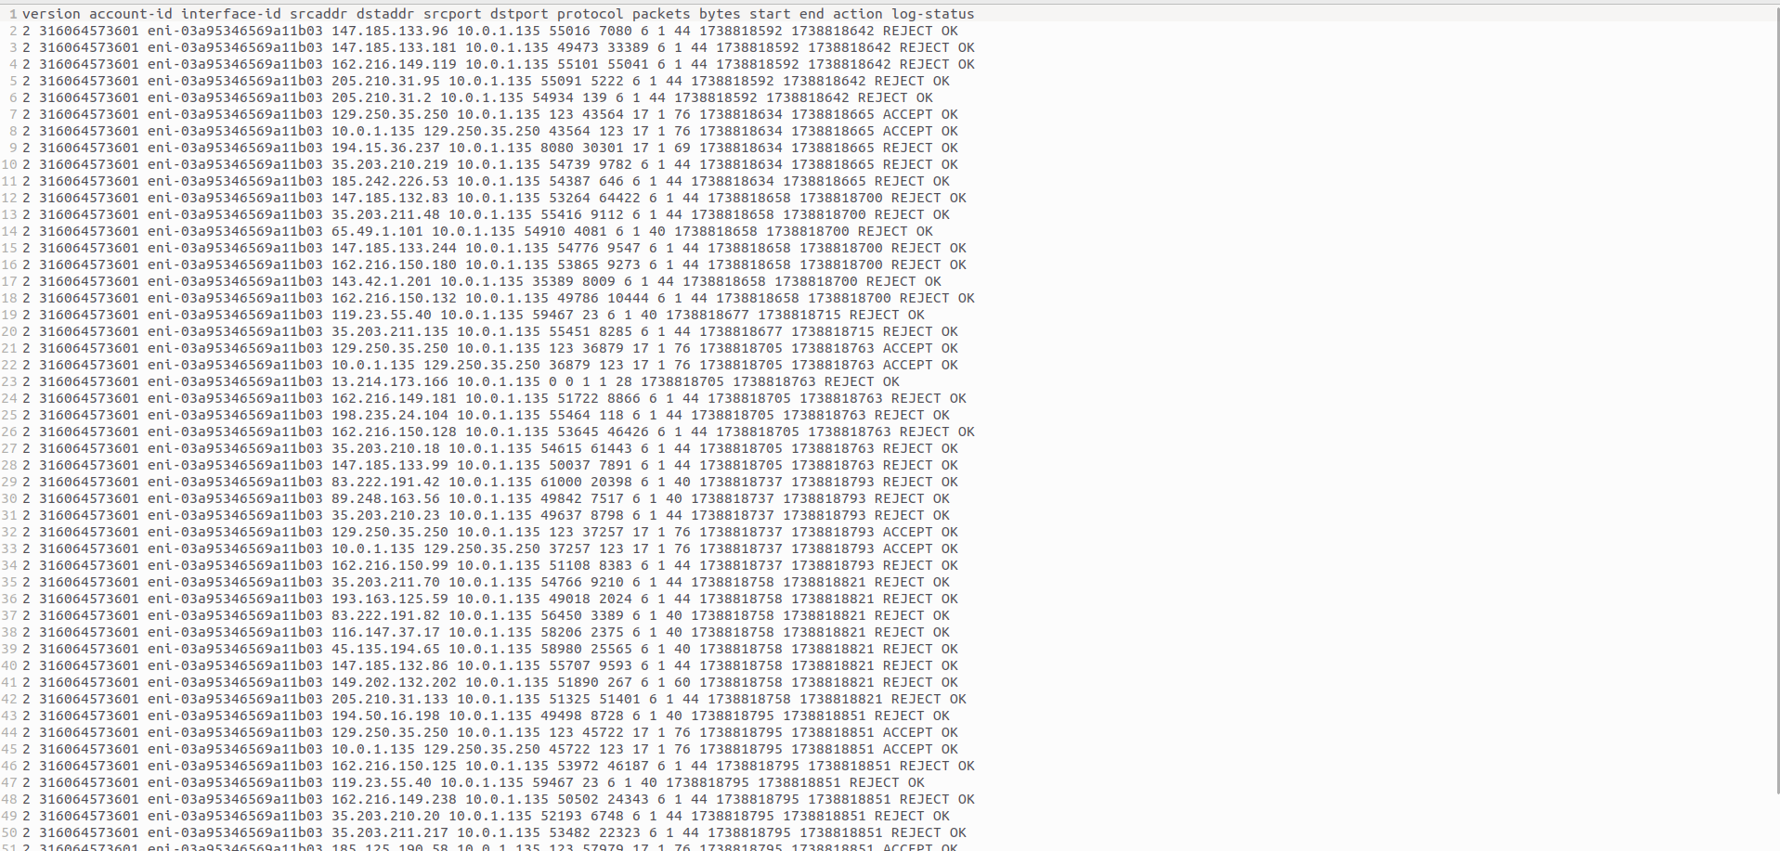
Things to Remember
- The URL expires after the set duration.
- If you need to revoke access before expiration, you must delete the object or change its permissions.

{ "Version": "2012-10-17", "Statement": [ { "Effect": "Deny", "Principal": "*", "Action": "s3:GetObject", "Resource": "arn:aws:s3:::your-bucket-name/your-object-key" } ] }
In Above policy Here change bucket name/Object Key

